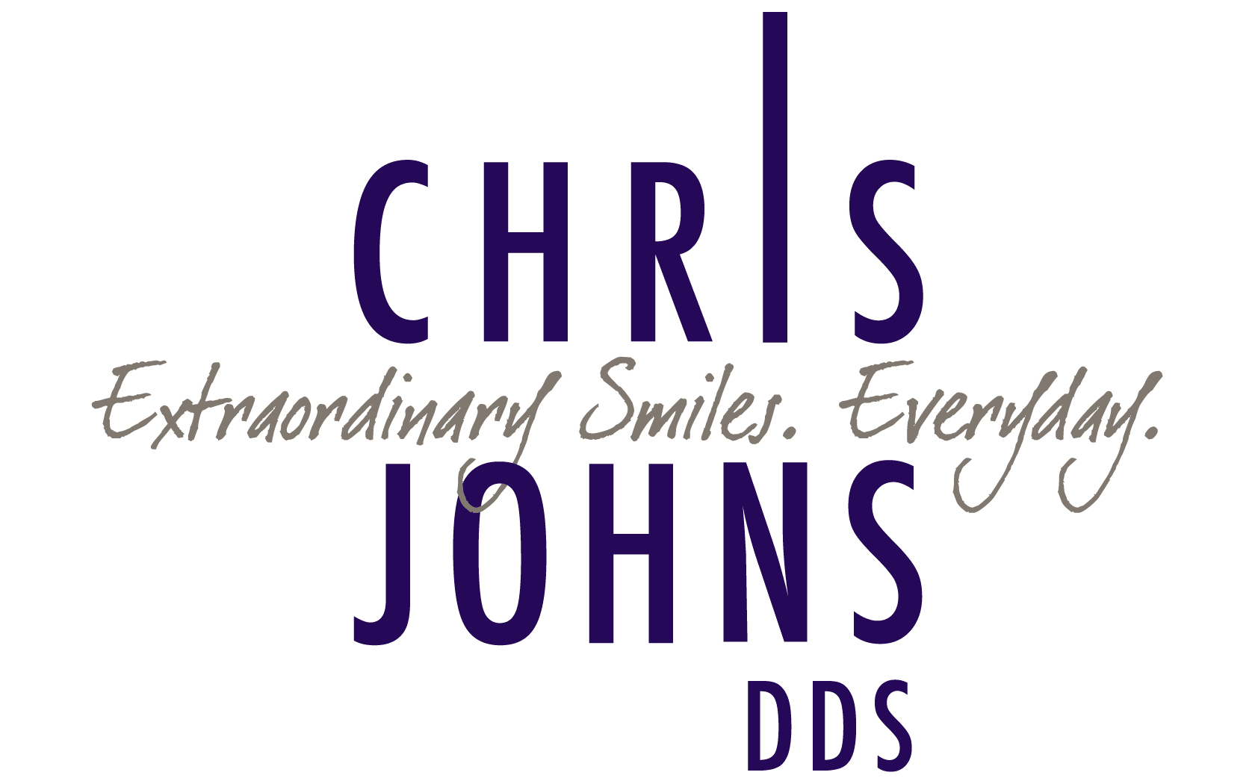
CONDITIONS OF TREATMENT AND FINANCIAL AGREEMENT
I voluntarily and knowingly request and consent to the services, treatments and/or procedures recommended by Dr. Johns and to all diagnostic methods deemed appropriate which may include, but not be limited to, x-rays, study models, imagery, and other aids. I authorize Dr. Johns to perform such services, treatments and/or procedures and to utilize all such diagnostic methods. Further, I acknowledge and understand that Dr. Johns may engage the assistance of other in performing such services, treatments and/or procedures and in utilizing such diagnostic methods.
I understand that the practice of dentistry is not an exact science and I acknowledge that no guarantees have been made to me concerning the results of the services, treatments, procedures and/or diagnostic methods that have been recommended.
I understand and acknowledge that I am fully and completely responsible for the payment of all costs associated with the services , treatments, procedures and/or diagnostic methods performed and utilized by Dr. Johns and others. I acknowledge that my insurance coverage benefit that I have is based on a contract between my insurance company and me, my spouse and/or my employer. The dentist is not a party to this contract and the services, treatments, procedures and /or diagnostic methods that are provided to me. Therefore, I acknowledge that I am fully responsible for the payment of all fees owed to the dentist for the services, treatments, procedures and/or diagnostic methods provided to me. As a courtesy to me, the dental office will bill my insurance company and I acknowledge that I will remain liable for any and all amounts not paid by the insurance company for any reason (including but not limited to the insurance company declining coverage after initially approving it) or if the insurance company fails for any reason to reimburse the dentist within 30 days after being billed by the dentist. I acknowledge that it is my responsibility to provide the dentist with my current insurance information and any changes thereto.
Any account balances that remain unpaid for 61 days for the date of service shall accrue interest at the rate of 18% per year and may be referred to an outside collection agency or attorney. In the event this occurs, I understand that I may be liable for collections costs as well.
I understand that as a courtesy to our office, if for any reason an appointment must be cancelled by the patient, 48 hours notification by telephone or email will be given to the doctor’s office (two working days). Failure to properly notify the office may result in charges at the usual rate for that appointment. Such charges are not reimbursed by insurance programs.
I have read and understand the above agreement and will abide by these policies.
Patient_____________________________ Date __________________________
Print Name____________________________

